Q: What are the different Type of testing you do on Mobile?

1. Usablity Testing :- It is easy to use and provide satisfactory user experience
2. Compatibality Testing :- Testing the app in the different devices ,browser, screen OS Version
3. Interface Testing :- Testing of menu Option, buttons, bookmark , history setting and navigation flow of application.
4. Services Testing :- Testing app Online and offline
5. Low Level Resource Testing :- Testing of memorey uses, auto deletion of temperoriey files etc
6. Performance Testing :- Testing app under different n/w : 2G,3G,4G LTE,WIFI , battery consumptions
7. Installation testing: Installing and uninstalling the app
8. Interrupt Testing:- getting the call or msg while working on app
9. Compatablity Testing: attache photos or videos from phone to msg
10. Security Testing :- to test if app data is secured or not.

<http://www.softwaretestinghelp.com/5-mobile-testing-challenges-and-solutions/>

<http://www.softwaretestinghelp.com/mobile-testing-interview-questions-answers/>

Q : **What are the types of mobile applications?**

**Ans.** Mobile applications are of three types:

**Native** **Application**– Native app installed from application store like Android’s google play and apple’ app store. The application which can be installed into your devices and run are known as native application for E.G. whats App, Angry birds etc.

**Web** **Application**– Web applications runs from mobile web browsers like Chrome, Firefox, Opera, Safari etc using mobile network or WIFI. E.G. of web browser applications are m.facebook.com, m.gmail.com, m.yahoo.com, m.rediffmail.com etc.

**Hybrid Application-** Hybrid apps are combinations of native app and web app. They can run on devices or offline and are written using web technologies like HTML5 and CSS. For E.G. ebay, flipkart etc

Q: Difference between Native and Web App testing?

Ans. .

Native apps have single platform affinity while mobile web apps have cross platform affinity.

* For a native app, installation is required but for mobile web apps, no installation is required.
* Native app can be updated from play store or app store while mobile web apps are centralized updates.
* Many native app don’t require Internet connection but for mobile web apps it’s a must.
* Native app works faster when compared to mobile web apps.
* Native apps are installed from app stores like [Google play store](https://play.google.com/store?hl=en" \o "Google app store" \t "_blank)or [app store](http://www.apple.com/osx/apps/app-store.html" \o "App store" \t "_blank) where mobile web are websites and are only accessible through Internet.
* Native apps are written in platforms like SDKs while Mobile web apps are written with web technologies like html, css, asp.net, java, php.
* (Chrome, Internet Explorer, Firefox, and Safari

Q: **How to test CPU usage on mobile devices?**

**Ans.** There are various tools available in the market like google play or app store from where you can install apps like CPU Monitor, Usemon, CPU Stats, CPU-Z etc these are an advanced tool which records historical information about processes running on your device.

Q : **When performing sanity test on mobile application what all criteria should be taken into consideration?**

**Ans.**

**Sanity Testing** is the subset of Regression **Testing** and it is performed when we do not have enough time for doing **testing**. **Sanity testing** is the surface level **testing**where QA engineer verifies that all the menus, functions, commands available in the product and project are working fine.

* Installation and uninstallation of the application
* Verify the device in different available networks like 2G, 3G, 4G or WIFI.
* Functional testing
* Interrupt testing- Able to receive the calls while running the application.
* [Compatibility testing](http://www.softwaretestinghelp.com/software-compatibility-testing/)– able to attach the photo in message from gallery
* Test application performance on different handset.
* Make some negative testing by entering the invalid credentials and test the behavior of the application.

Q: **Which things to consider testing a mobile application**[**through black box technique**](http://www.softwaretestinghelp.com/black-box-testing/)**?**

**Ans.**

* By testing your application on multiple devices.
* By changing the port and IP addresses to make sure the device is getting connected and disconnected properly.
* By making calls and sending messages to other devices.
* By testing your web application on different mobile browsers like chrome, Firefox, opera, dolphin etc.

Q: **What is the basic difference between Emulator and Simulator?**

**Ans.** Emulator is based on hardware and software wherein simulator is based on software. Simulation is system that behaves *similar*to something else while emulation is system that *exactly*behave like something else.

Q: **Name debugging tools for mobile?**

**Ans.** Errors can be verified by the generated logs. We can use configuration utility on iOS and android monitor.bat on android. Here are few to name Android DDMS, Remote Debugging on Android with Chrome, Debugging from Eclipse with ADT, Android Debug Bridge, iOS simulator etc.

Go to google search for iphone configuration utility-> download for mac or windows and setup this with email and p/w.

Go to configuration Utility ->connect phone through uSB cable ->start showing phone under Device

* From Android Studio, choose Tools > Android > Android Device Monitor or click the Android Device Monitor https://developer.android.com/images/tools/hierarchicalviewer-icon.png in the toolbar.

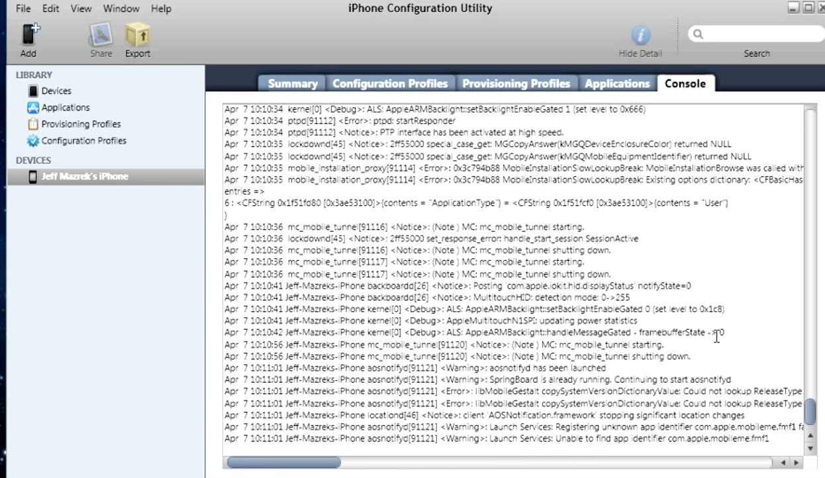

Q : **What is the strategy used to test new mobile app?**

**Ans.**

* System integration testing
* Functional testing
* Installation and uninstallation of the app
* Test HTML control
* Performance
* Check in multiple mobile OS
* Cross browser and cross device testing
* Gateway testing
* Network and Battery testing

Q: **What does a test plan for Mobile App contain?**

**Ans.** Test plan for mobile app is very similar to software app

1. Objective
2. Automation tools required
3. required features to be tested:
   * network
   * security
   * performance
   * size
   * battery
   * memory
4. features not to be tested
   * display size
   * resolution
5. Test cases
6. Test Strategy
7. Tested by
8. Time required
9. No. of resources required

Q: **Full form of the various extensions**

**Ans.**

* apk – Android Application Package File
* exe – Executable Files
* iPA –iOS App Store Package
* prc – Palm Resource Compiler
* jad – Java Application Descriptor
* adb – Android Debug Bridge
* Aapt**–**Android Asset Packing Tool

Q: Mobile testing chalanges

* 1. These huge number of mobile devices availability ranging from handsets, to smart phones, to tabs, to ipads and wearable tech provides a huge diversity of environments which your mobile app faces.
  2. Perhaps the most difficult aspect of the mobile testing matrix is device fragmentation. Though the iOS device matrix is growing more than ever, fragmentation is especially an issue for the Android operating system.
  3. A mobile app can be a native app, a web app or a hybrid app which has both contents. Testing of each such app type is different than another as their implementation is quite different from one another.
  4. Mobile emulators and simulators are important testing tool and they enable us to verify general functionality and perform [regular regression testing](http://www.softwaretestinghelp.com/regression-testing-tools-and-methods/). The very character of emulators and simulators means testing is being conducted in an environment which is not real.
  5. Summarizing the daunting complexity of mobile test automation, even more daunting is the huge availability of mobile test automation tools in the market. Free/Paid. For native app or web app? For android or for iOS, so which is the one automation tool for your mobile test automation needs, or the question is – Is there a single tool for our Mobile Test automation needs?

Q: How to install IPA files on IOS device?

Before we install IPA file in the device we need to do some settings:

IOS -Go to Device->Settings->Privacy->Diagonstic and Data -> Diagonstic and Data Usage

Android - Go to setting-> About Phone ->S/w information -> Build Number -> click or Tab 7 times on build number.

**Steps to install IPA files on an iOS device:**

1. **Installing through iTunes**

Download the IPA file on your local machine

1. Connect the device to the local machine
2. Trust the computer on the device
3. Once connected, iTunes will launch automatically
4. Add the downloaded IPA file into the Apps directory in iTunes

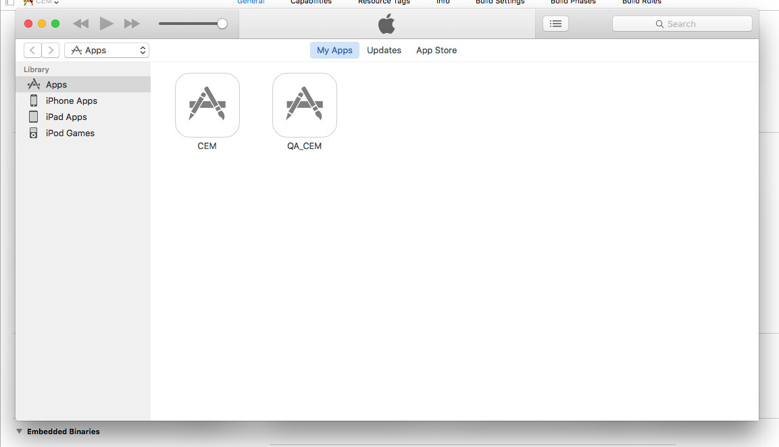

1. Once it is added, go to the device by clicking the device icon (http://help.apple.com/iphoto/iphone/2.0/en.lproj/Art/IL_iPhoneIconMac.png) in iTunes

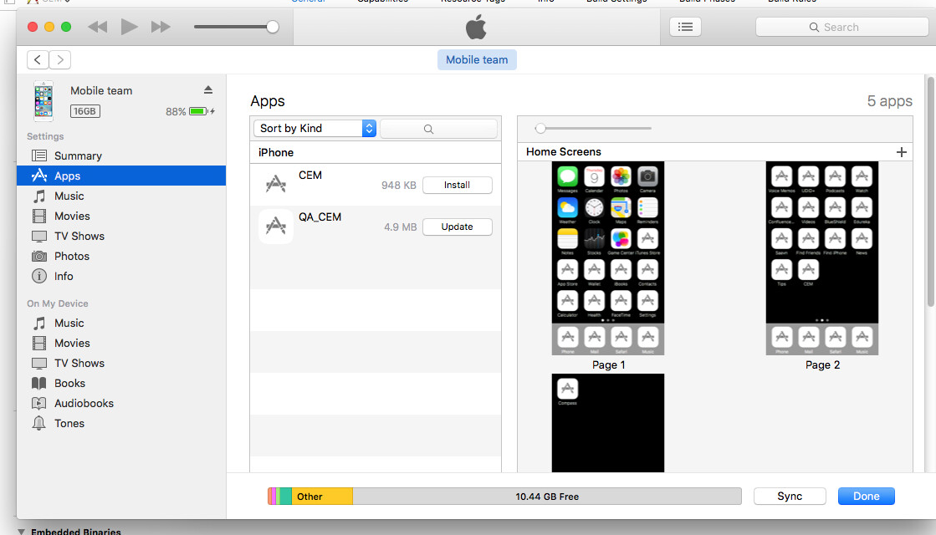

1. Go to apps directory
2. Now, you will be able to see the list of IPA files available to install on the device
3. Click install for the IPA file which you want to install

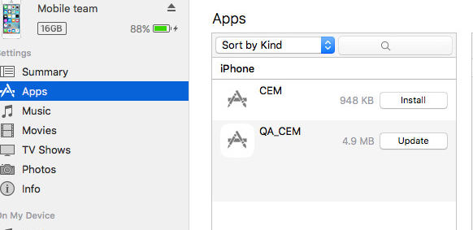

1. Click apply on the bottom of the iTunes and Sync the device

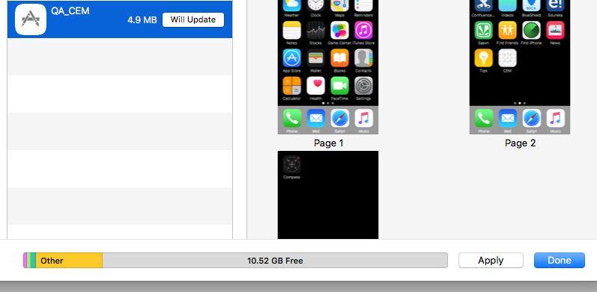

1. After successful sync the IPA file is installed on your device.

Q: How to Install apk file in Android emulator or Android Device.

There is 3 ways to install apk in the Phone :

To install any apk file in phone Developer Option should be enable.

How to enable developer options:

Go to setting-> About Phone ->S/w information -> Build Number -> click or Tab 7 times on build number.

Option: 1

1. **Enable Unknown Sources**

Before attempting a manual installation of apps using the .apk files, you must first allow phone to

install from “Unknown Sources” (i.e. non-Play Store apps).

To do this, navigate to Settings -> Security 🡪 and check the box marked “Unknown Sources“.

Option: 2

Another way of apk side load - enable device USB configuration to view mobile file system in computer

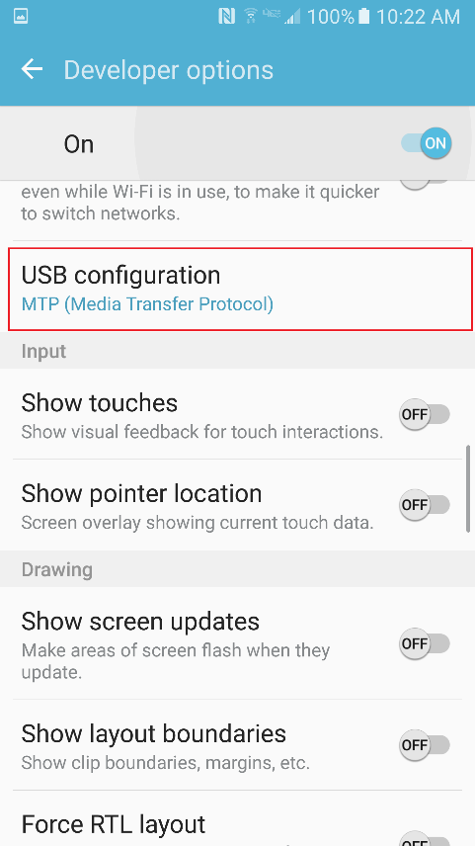 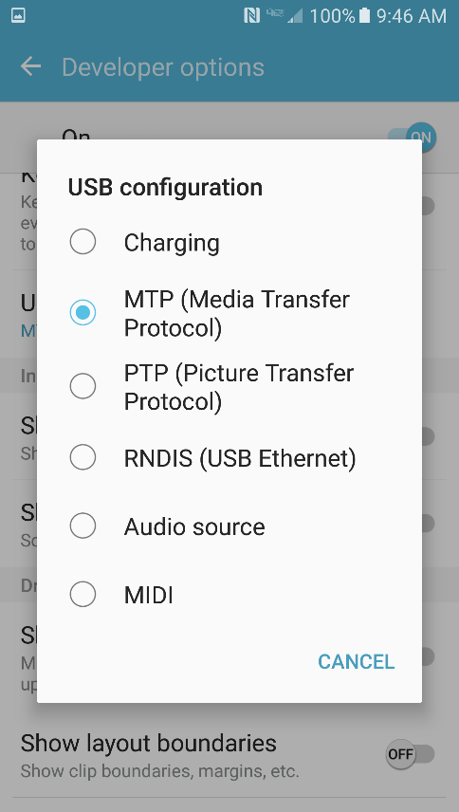

After the above change , we should be able to see phone drive

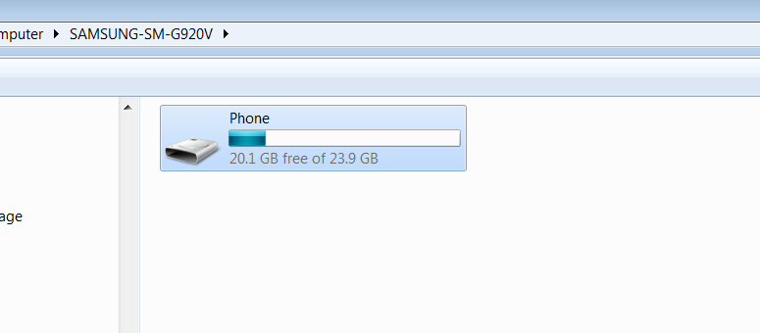

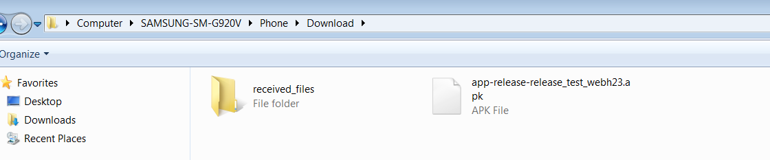

After opening device download folder, we can copy apk file from desktop to device

Option: 3

Installing using command prompt

Note: to run the above command make sure android sdk installed in your local, and also PATH variable

Configure the ANDROID\_HOME environment variable based on the location of the Android SDK. Additionally, consider adding ANDROID\_HOME/tools, and ANDROID\_HOME/platform-tools to your PATH.

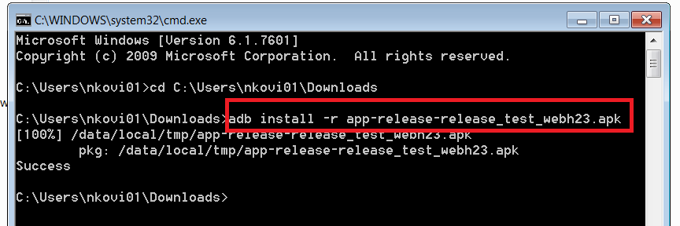

Connect your device using USB cable, and run the above command

C:\Downlaods>adb install -r your-apk-file-location

Q: How to create Simulator using XCODE?

A: Go to Xcode ->Windows->Devices

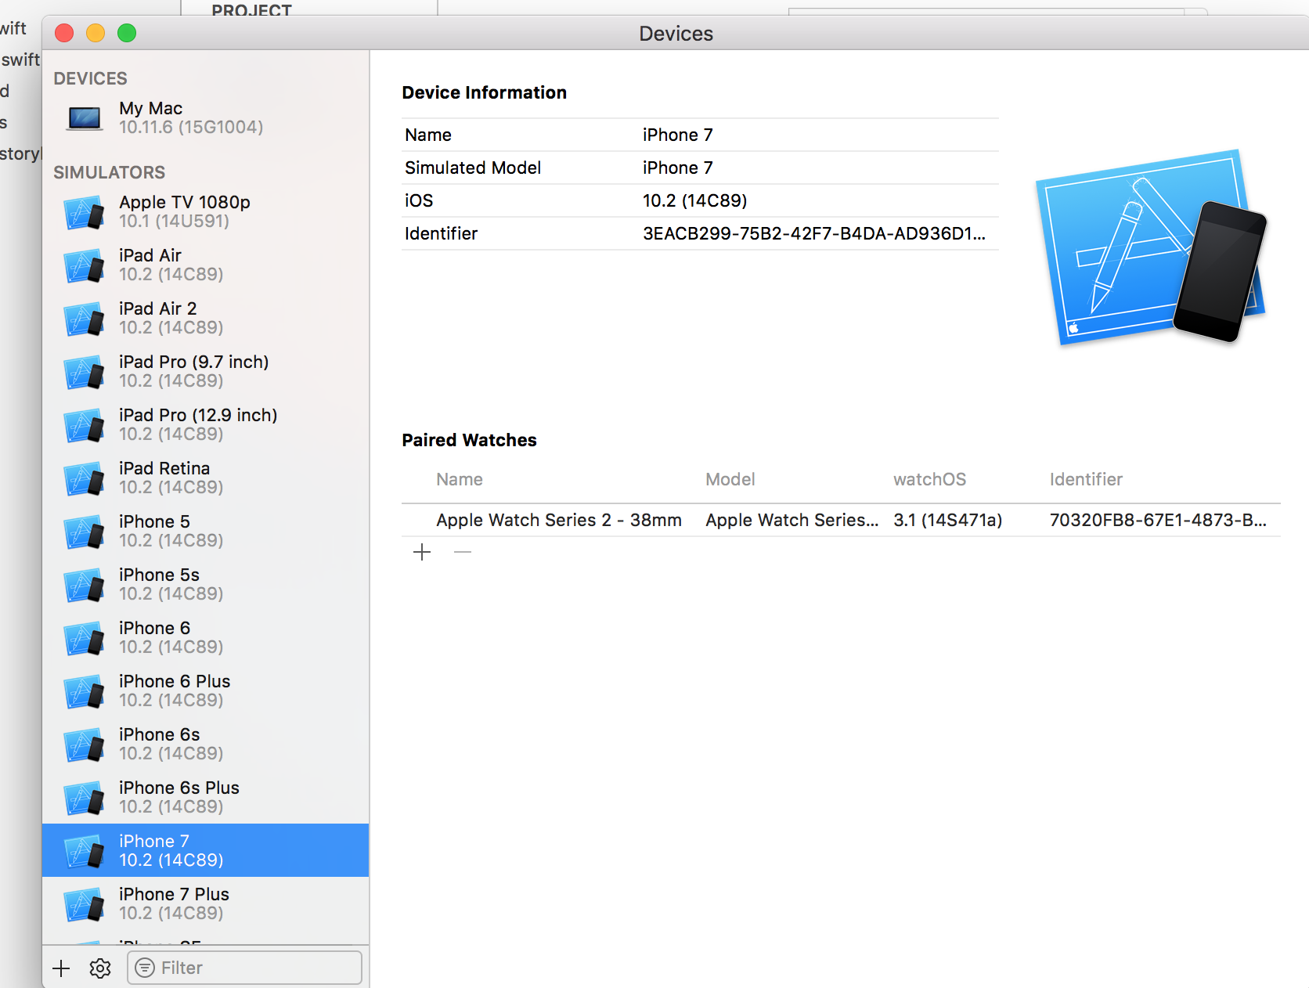

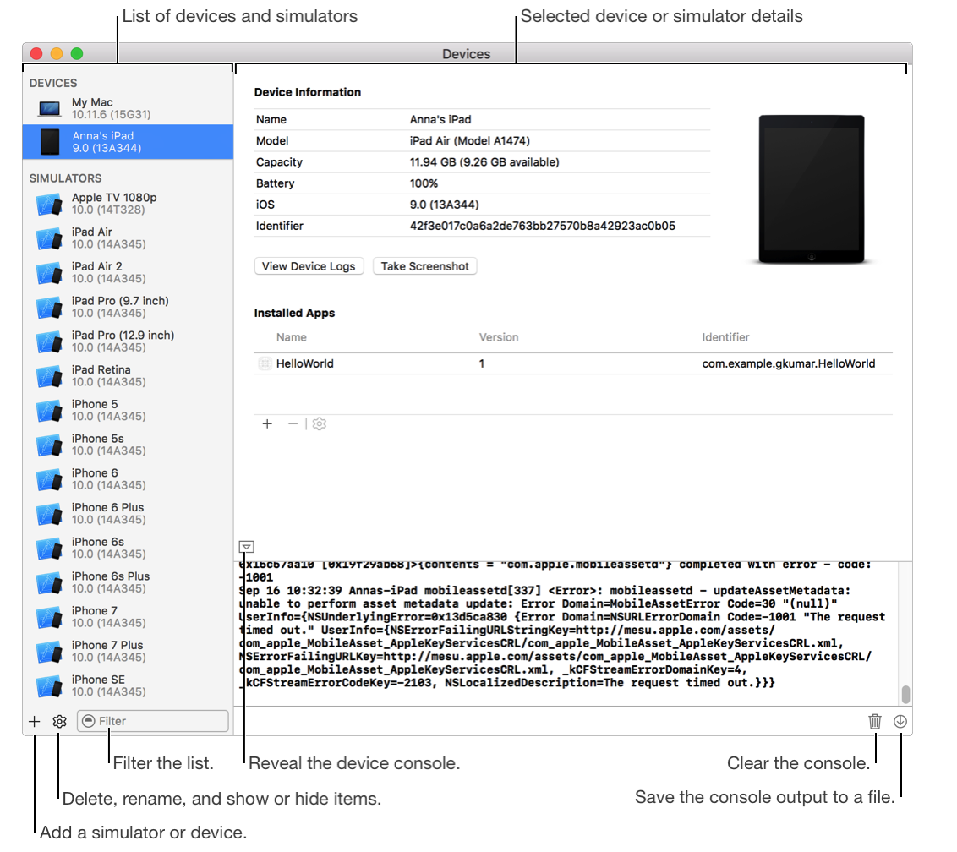

**Install an app using XCode**

* Open the Devices window (choose Window > Devices).
* Under Devices, select your device.
* Under Installed Apps, click the Add button (+).

In the sheet that appears, select the iOS App file and click Open.

**Uninstall an app**

* Under Devices, select your device.
* Under Installed Apps, select the app you want to remove from the list. You can select only the apps that you created. You can’t uninstall any of the system-installed or third-party apps.

Click the Delete button (–) below the table, and in the sheet that appears, click Delete. For watchOS apps, Xcode removes the WatchKit extension app on the iPhone and the WatchKit app on the paired Apple Watch. 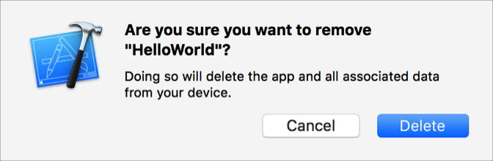

Q: How to view device logs in Xcode

A:

**View a log on a device**

* For iOS and tvOS apps, connect a device to your Mac. For watchOS apps, connect an iPhone paired with an Apple Watch.
* Open the Devices window (choose Window > Devices).
* Under Devices, select your device and click View Device Logs. A sheet displays the crash logs.
* In the left column, select the crash log you want to view. The crash log content displays on the right.

Click Done.

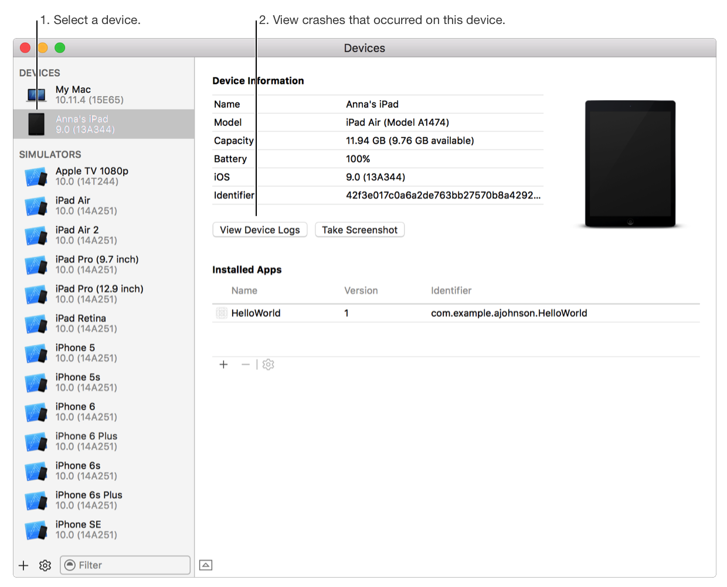

Q: How to import log from device to your computer?

**Import and view a crash log**

* In the Devices window, select a device under Devices, and click the View Device Logs button.
* Drag the crash log from the Finder to the left column of the sheet.
* In the left column, select the crash log. The crash log appears in the detail view on the right.

Click Done.

OR

Go to Device->Settings->Privacy->Diagonstic and Data -> Diagonstic and Data Usage -> Select -> Send log file by email or message

Q : What is TestFlight?

A : TestFlight

The TestFlight app allows testers to install and beta test your app on iOS, tvOS, and watchOS devices. Testers must receive an invite directly from developer before they can begin testing with TestFlight. Once testers accept developers invitation, they can install, test, send feedback, and get updates of your beta app.

To use TestFlight, you upload your app to iTunes Connect and then use iTunes Connect to invite testers. Optionally, distribute your app to internal testers (your iTunes Connect users) or external testers (users with email addresses). If you invite any external testers, your app is submitted to Beta App Review.

Apple provides a crash report service that allows you to view crash reports directly in Xcode for apps distributed using TestFlight.

Q: What is Android Debug Bridge (ADB)?

ADB is a versatile command-line tool that lets you communicate with a device (an emulator or a connected Android device).

Using adb we can Install/UnInstall and debug the app along with collecting the Logs and Bug Reports.

To use adb with a device connected over USB, you must enable USB debugging in the device system settings, under Developer options.

Enable Developer Option :- Go to Phone Sttings ->About Phone->S/W Information ->Build Number ->Click ot Tab 7 time on Build Number

Q: How to do testing on android using ADB commands?

1. Device is connected with the system using usb cable.
2. It should have a “Developer Option” Enable
3. Find the IP address of the Android device. For example, on a Nexus device, you can find the IP address at **Settings** > **About tablet** (or **About phone**) > **Status** > **IP address**. Or, on an Android Wear device, you can find the IP address at **Settings** > **Wi-Fi Settings** > **Advanced** > **IP address**.
4. Connect to the device by its IP address.

=🡺 adb connect device\_*ip \_*address

5. Confirm that your host computer is connected to the target device:

=🡺 adb devices -l

It will show list of all the android devices

Q: How to install apk binary using adb commands?

./adb install –r /user/mydocument/Download/app-debug.apk

It will install and replace the existing app with new app.

Q: How to uninstall apk using adb command?

A : ./adb shell pm uninstall –k package name

Using “-k” we can keep the device data, OW it will remove all the data from device

Q: How to get the log from adb command?

A: ./adb logcat –d> /File Path/FolderName/FileName with extention (.txt or .pdf or .doc)

Q: How to get the Bug Report?

A : ./adb bugreport >FilePath>Folder FolderName/FileName with extention (.txt or .pdf or .doc)